- Press Release -
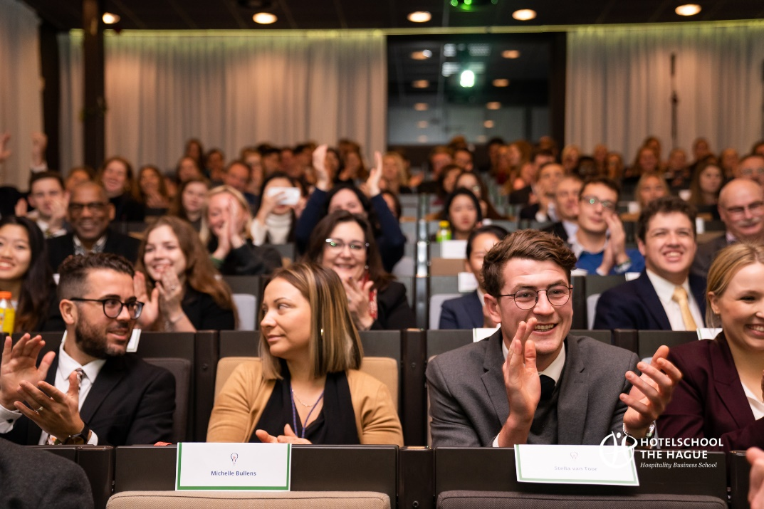
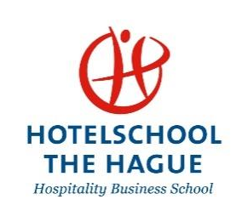

The Hague, 11 February 2021
Sustainable Hospitality Challenge forges partnership for a sustainable planet

The investment community and the next generation of hospitality leaders unite in a global student challenge

With leading events’ organiser Bench and the Sustainable Hospitality Alliance on board, a beneficial partnership has been created for all parties involved in the Sustainable Hospitality Challenge. This collaboration is about pushing the boundaries of innovation to create value-added solutions for a more sustainable world.

The Sustainable Hospitality Challenge (SHC) is a Hotelschool The Hague initiative that aims to enhance the evolution of sustainable hospitality. Launched 6 years ago as the ‘Genio Worldwide Innovation Summit’, the challenge has now moved to a new direction embracing sustainability as the recurring theme. SHC addresses the urgency of the climate crisis and the direct impact it has on travel and tourism – an impact that has engaged all participants to contribute with innovative solutions. Today, more than 60 students from 30 global top-tier hospitality business schools share their ideas for a better Planet!

The stage is set with international hotel school students being invited to develop sustainable solutions in the fields of Future Brand, Future Real Estate and Hospitality of Tomorrow, which they pitch to a prominent jury of senior industry leadership and hospitality CEOs.
The idea behind the SHC initiative was to elevate the student journey and put innovation at the forefront of the industry ecosystem. Paul Griep, Director of Industry Relations at Hotelschool The Hague and the driving force behind the challenge said; “This is the largest student sustainability challenge in our industry. Our mission is similar to the World Solar Challenge where ideas and solutions presented by the students are adapted and used in the real world.”
Now an exciting new partnership between Bench Events will bring a new dimension to the challenge. “We are honoured to partner with such a global industry events organiser that will showcase innovative talents and will introduce a new edge to this challenge”, Griep said “This initiative presents a unique opportunity for the next generation of hospitality leaders to build sustainable solutions with a global outreach and outcome.”
On occasion of this partnership, Jonathan Worsley, Chairman of Bench, said “Showcasing an international pool of talent, eager to present innovative ideas on a global stage is the most rewarding part of the alliance. Bringing together a generation of creative change-makers and the investment community will shape the cradle of innovation and will lead us to a more sustainable world. We can do this only when collaborating and listening to the new generation.”

A leading supporter of the challenge is Wolfgang M. Neumann, chairman of the Sustainable Hospitality Alliance – a global forum of industry CEOs who are committed to a resilient and sustainable future - who is also chairman of the Board of Trustees of Hotelschool The Hague. He said: “Responsible travel recovery, impactful leadership and resilience in all planet-affecting initiatives are critical for the industry and the planet. All decision-makers need to collectively ensure that together we support the future leaders in building sustainable growth.”

Marloes Knippenberg, CEO of Kerten Hospitality who is also a Co-Chair of SHC, believes that the student challenge has been created by the students and for the students. “Multiple inventions have evolved as a result of a challenge and our industry is no stranger to experiencing fast-forward progress only by connecting the business world with Generation Z that pioneers the most innovative ideas. New concepts need to be visible to the business and investment communities – a vital role that not only leads to opportunities for many but accelerates the speed of development in our industry and supports a mindset-reset towards a more sustainable world.”

To qualify for the SHC, all teams delivered their first report describing their innovative ideas in November 2020. Previews of some of those reports can be found on thestudentchallenge.com website. The quarter-final and semi-final will take place online on 31 March 2021, leaving just three teams in the final which will take place at the Arabian Hospitality Investment Conference (AHIC) later this year. Top tier industry CEOs will be judging and awarding the winning team. If you want to follow the students’ journey this year, connect on LinkedIn, follow them on Instagram and tune in to the website: www.thestudentchallenge.com

Hotelschool The Hague
Hotelschool The Hague was founded in 1929, making it one of the oldest independent hotel schools in the world. Since 1929, Hotelschool The Hague has been renowned for its education and innovative research and is ranked among the Top 5 Hospitality Management Schools in the World. The school has two campuses, one in The Hague and one in Amsterdam with over 2900 students and 200 employees. Since 2014 Hotelschool The Hague has been the best public Hotelschool in the Netherlands, according to the Dutch National Student Survey. Hotelschool The Hague offers the best Master in Business Administration in the Netherlands, according to Keuzegids Master 2019. Graduates of Hotelschool The Hague occupy leading positions in the hospitality industry all over the world. www.hotelschool.nl

